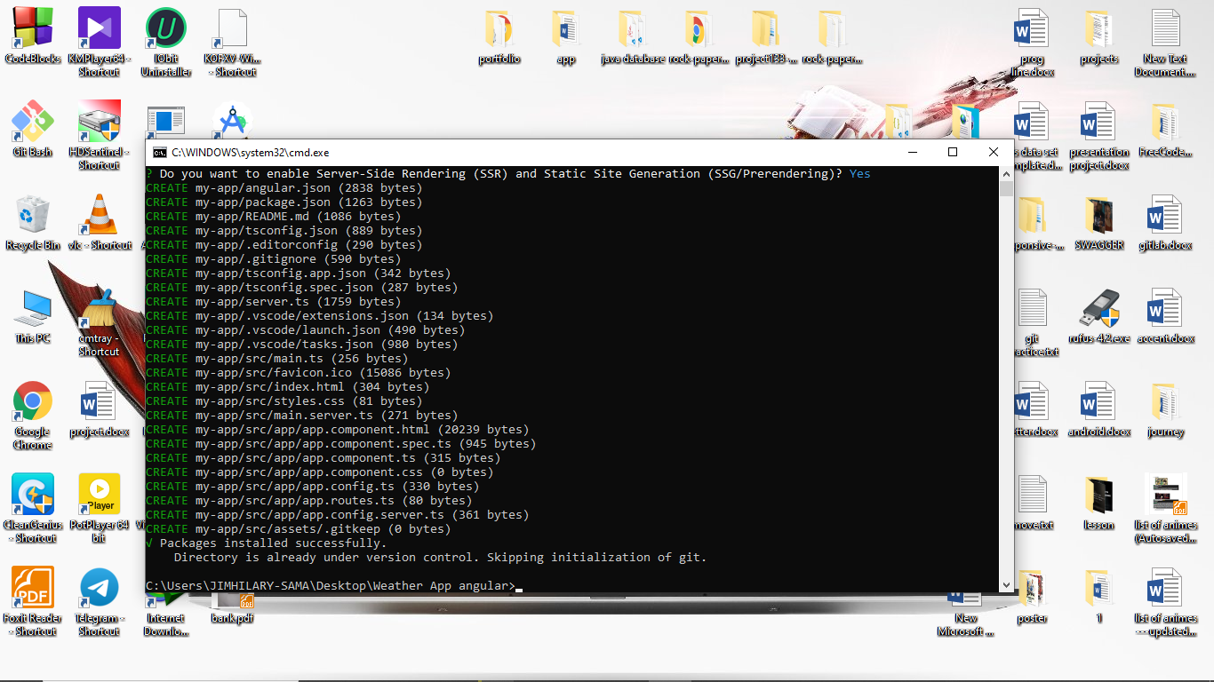

ng new projectName --no-standalone for modue.ts

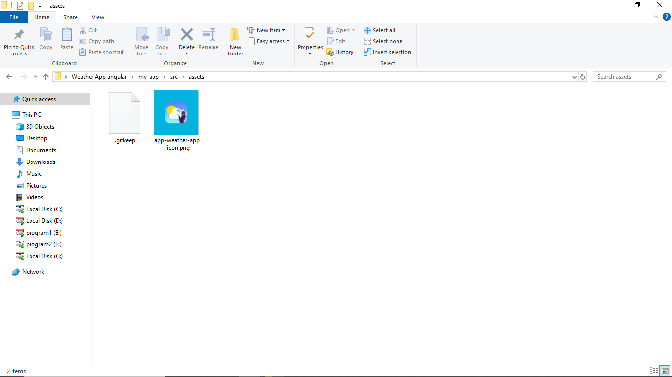

https://rapidapi.com/hub